

**Faculty of engineering - Shoubra**

**Benha University**

**Research Project / Literature Review**

in fulfillment of the requirements of

|  |  |
| --- | --- |
| **Department** | **Engineering Mathematics and physics** |
| **Division** | **---------** |
| **Academic Year** | **2019/2020 – preparatory** |
| **Course name** | **Computer** |
| **Course code** | **ECE001** |

**Title: -**

**Building a Website about :**

**" computer Engineering role in Covid-19 pandemic "**

By:

|  |  |  |  |
| --- | --- | --- | --- |
|  | Name | Edu mail | B.N |
| 1 | Mina Gamal Takwa Hana | mina196094@feng.bu.edu.eg | 972 |

**Approved by:**

|  |  |
| --- | --- |
| Examiners committee | Signature |
| Dr.Ahmed Bayoumi |  |
| Dr.Shady Elmashad |  |
| Dr. Abdelhamid Attaby |  |
|  |  |
|  |  |

**Links**

**The Github repository of the project**:

<https://github.com/minagamaltakwa/ECE001>

**The Github pages link of the project**: ( the link of the website )

<https://minagamaltakwa.github.io/ECE001/>

**Objectives**

The report include the following :

* Links of web site
* Introduction about the web site
* An abstract about computer engineering role in covid -19 pandemic
* Some screenshots to the web site and some photos of the source codes
* References

**Introduction**

**HTML** : it can be called as Hypertext Markup Language (HTML), it is the foundation of all the web pages

It describes the structure of web pages and it consists of number of elements

And we know that .. these elements can be represented by tags and these tags label pieces of contents as "heading", "paragraph", "table"

HTML tags are elements names surrounded by angle brackets as < , >

< this is called starting tag , > and this is closing tag ….

**The History of HTML**

HTML was firstly created by **Tim Berners Lee**  **, Robert Cailliau ,** and others starting in **1989**.

So we can ask what is the meaning of **HTML ??**

**Hypertext means :** the document contains **links that allow the reader to jump to other places** in the document or to the another document alltogether. And The latest version is known as [HTML5](https://html.com/html5/).

**Markup Language**  : is the way that computers can speak to each other to control how text can be processed and presented. into doing this HTML uses two things: tags and **attributes ..**

So th website we created will talk about an important topic

**" computer engineering role in Covid – 19 pandemic "**

**Literature Review**

**Computer engineering role in COVID - 19 pandemic**

A [corona virus](https://www.webmd.com/lung/coronavirus)  is a kind of virus that can causes an infection in your nose, [sinuses](https://www.webmd.com/allergies/picture-of-the-sinuses), or upper throat. corona virus disease 2019 (COVID-19) pandemic has made a number of weaknesses in the world’s healthcare systems and in global economy.

**So what are the reasons for choosing this topic in this web site ?**

In the web site we want to know what is the role of computer engineering in

COVID - 19 pandemic

**The field of computer engineering can help in this case as it :**

In statistics and calculating of the number of cases all over the world

And it also can determine the graphs of all world cases

This isn't the only reason … but the help of computer engineering in this pandemic is great as thenew team of engineers and computer scientists they argue that the current pandemic moment has to serve as a wake-up call for society and the public health in world community to give the opportunities of robotics

As “Robots have the ability to be deployed for disinfection, delivering medications and food, measuring vital signs, and assisting border controls,”

**they can help doctors at their work**

**Computer engineers have worked for** The group is developing a telemedicine platform, called [TV CV19](https://github.com/KastnerRG/TVCV19), designed to enhance hospital-wide communications and help medical specialists to care for more patients and Clinicians with the most care experience

**So , no one can deny the importance and applications of computer engineering role in Covid -19 pandemic ..**

**So that the created web site will state that topic and it's importance**

**Screen shots and Explaination**

**(screen shots for the web pages and the source code of the web page )**

First , We will start with screen shot of the index (home page) :

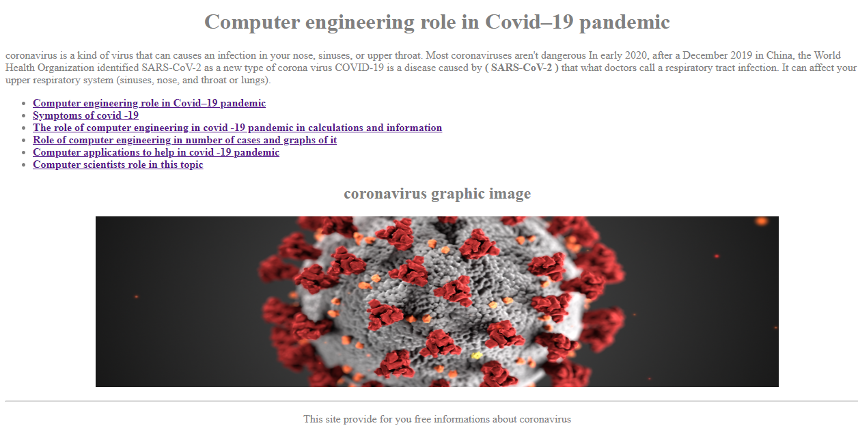

By starting with simple website we the back ground with (off- white ) color and the writing with (grey color) except the hyper links …this website is consists of 6 hyperlinks as :

* **Computer engineering role in COVID - 19 pandemic ( home page )**
* **Symptomps of covid -19**
* **Role of computer engineering in calculations and information**
* **Role of computer engineering in no. Of cases and graphs of it**
* **Computer applications to help in covid – 19 pandemic**
* **Computer scientists role in this topic**

And this is ascreen shot for the **home page code** :

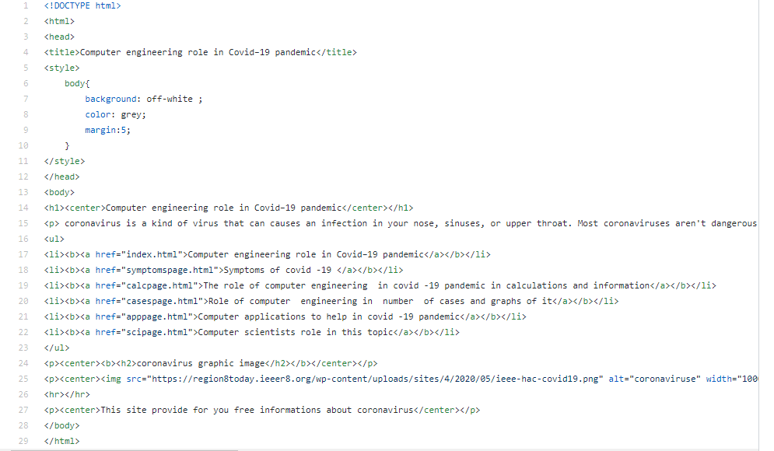

Note .. **we can see the code of the image as :**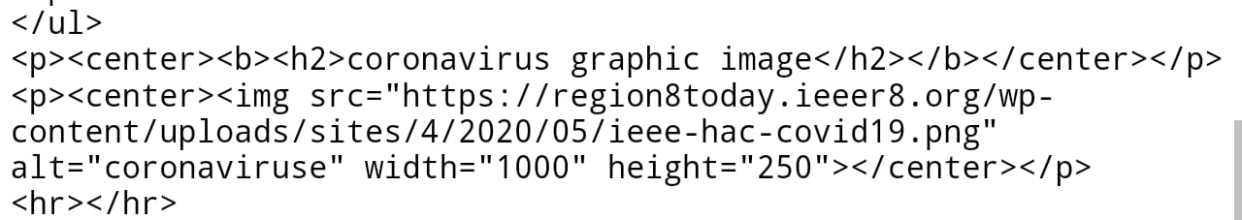

And this is a screen shot for the code of the 6 hyperlinks and it is created by **ordered list tag and hyperlinks** :

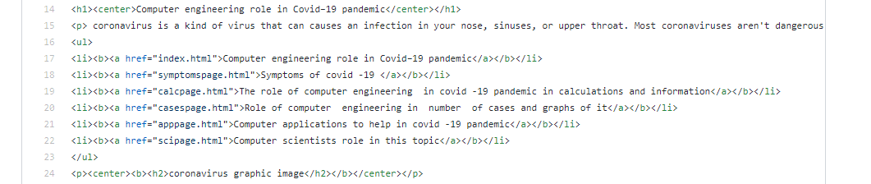

So let's see the first page of the website  **: Symptomps of covid -19**

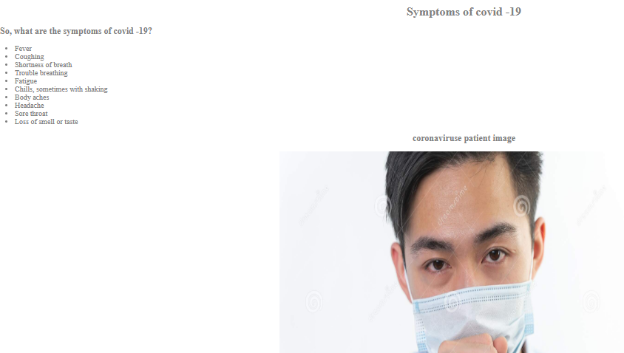

And it's code as an ordered list :

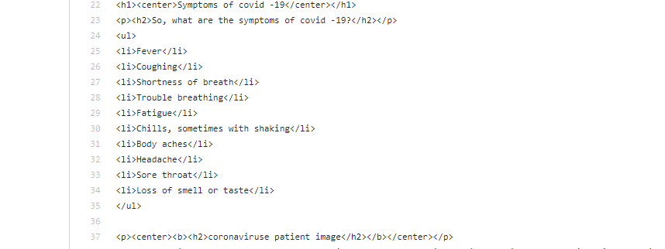

Now the page of : **Role of computer engineering in calculations and information** 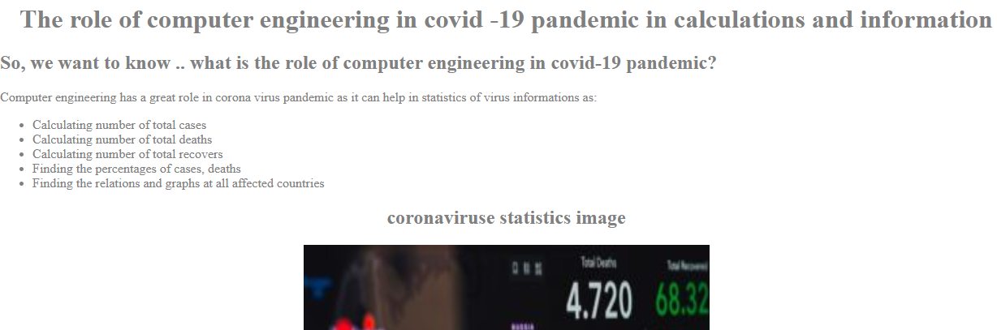

**And it's code :**

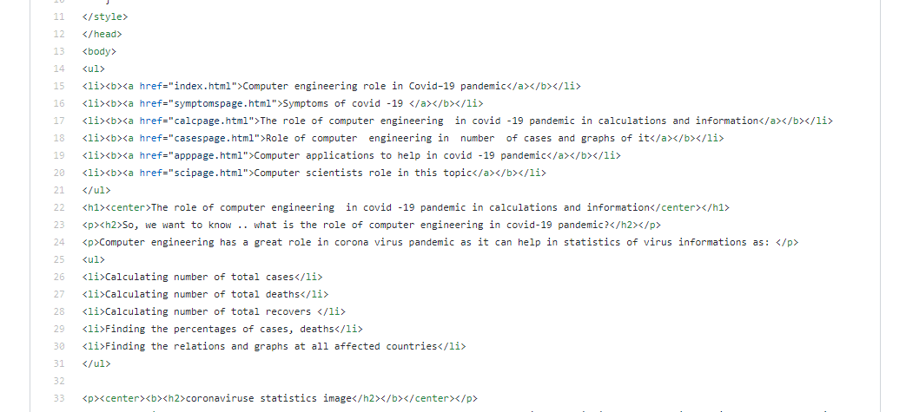

**And the page of : Role of computer engineering in no. Of cases and graphs of it**

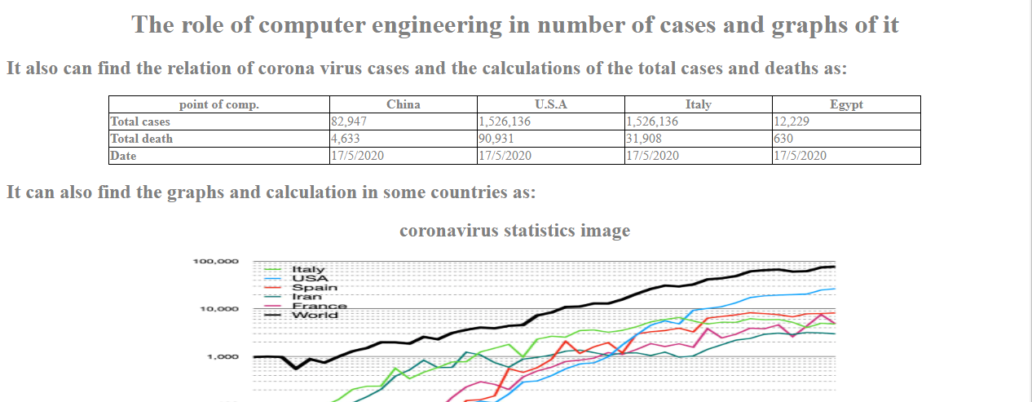

We see in the last screenshot the page contains a table we will see it's code in this screen shot

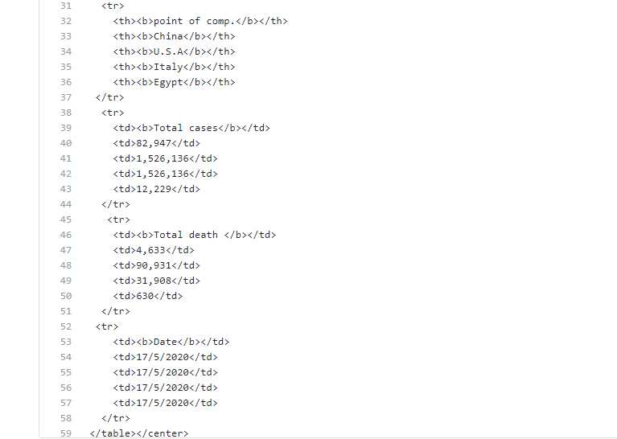

We will see the page of **Computer applications to help in covid – 19 pandemic**

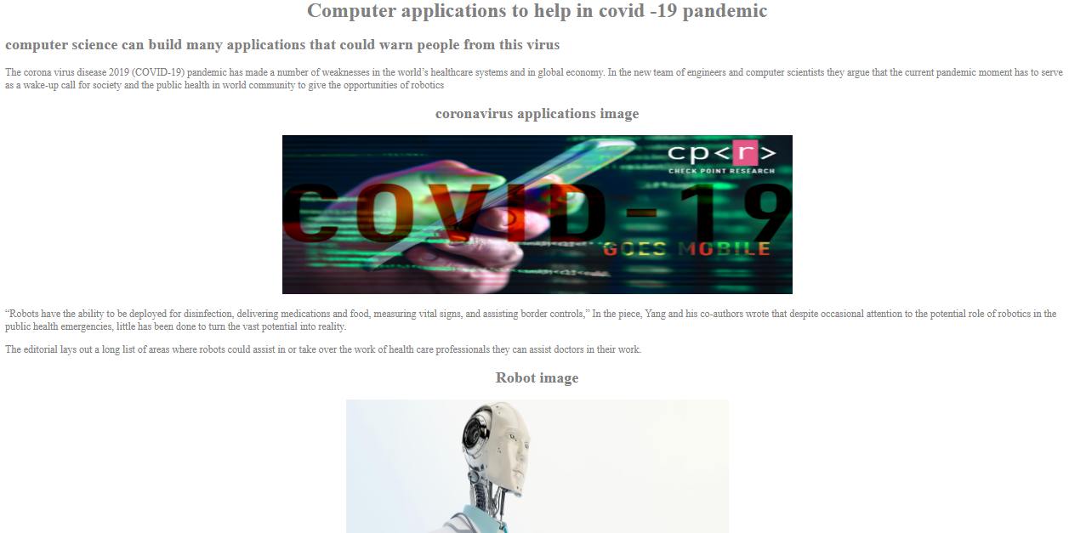

It's code :

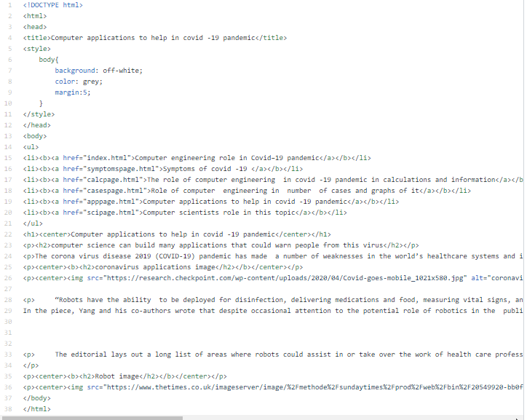

We will see the last web web page and it's codes as :

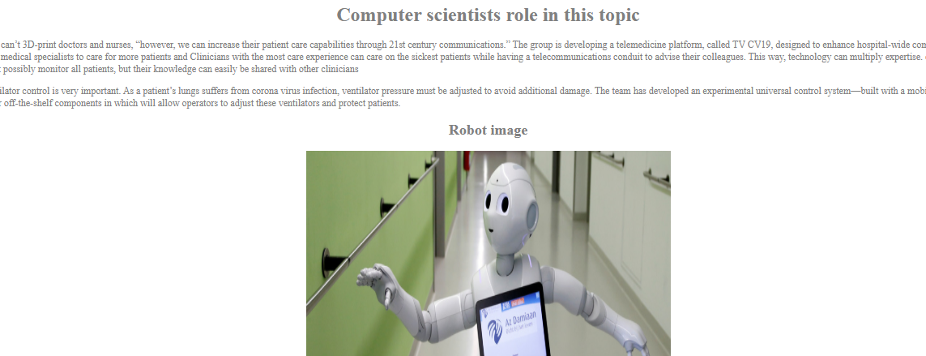

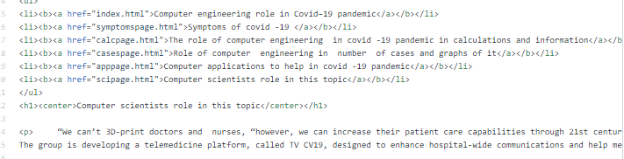

**References**

* **Egyptian Knowledge Bank, EKB**.
* www.researchgate.net/post/How_can_computer_science_contribute_to_stop_the_COVID-19_pandemic. <https://www.researchgate.net/>
* “Move to Bolster Resilience Post-Pandemic Is a Boost for Batteries.” *Business*, 20 May 2020, sciencebusiness.net/.<https://sciencebusiness.net/>
* “Better Information. Better Health.” *WebMD*, WebMD, www.webmd.com/. <https://www.webmd.com/>
* <https://www.w3schools.com/>